Java Stream API with Collections + 50 Advanced Java Collection Coding Problems
The Java Stream API (introduced in Java 8) allows developers to process collections using a functional programming style. Streams enable filtering, mapping, sorting, aggregation, and transformation of data in a concise and readable way.
Streams work with collections such as List, Set, Map, etc.

1. What is Java Stream API?
A Stream represents a sequence of elements supporting functional-style operations.
Key characteristics:
- Does not store data
- Processes data from collections
- Uses lambda expressions
- Supports parallel processing

Basic Pipeline
Collection → Stream → Intermediate Operations → Terminal Operation
Example:
List<Integer> numbers = Arrays.asList(1,2,3,4,5);

numbers.stream()
.filter(n -> n % 2 == 0)
.forEach(System.out::println);
Output
2
4

Stream Processing Pipeline
z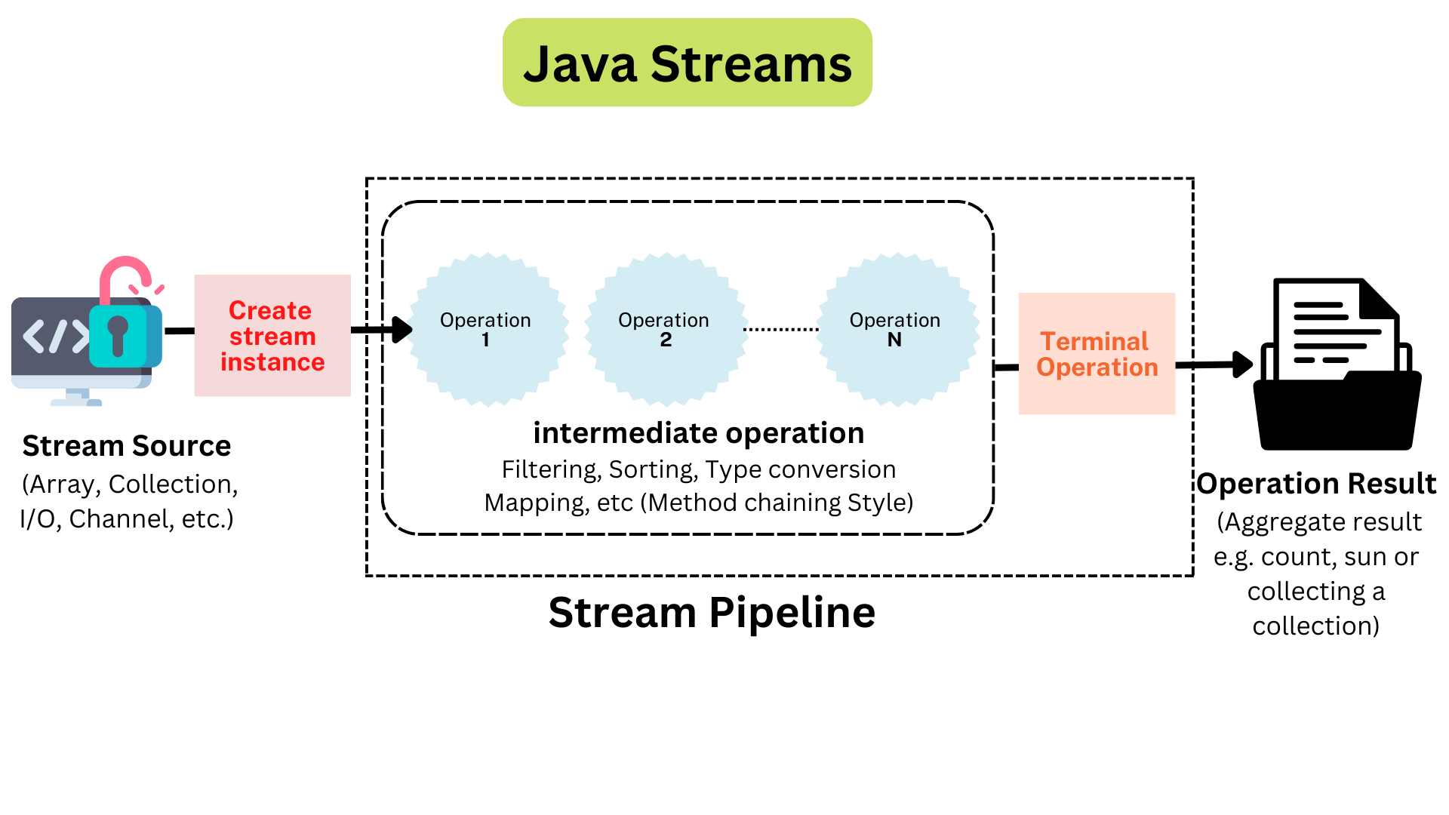
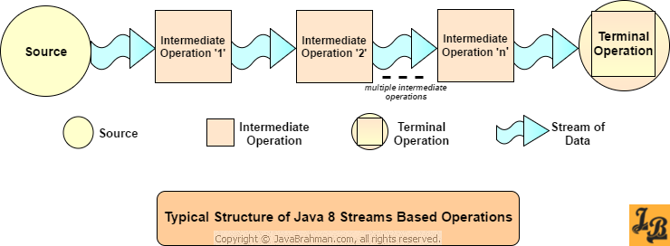
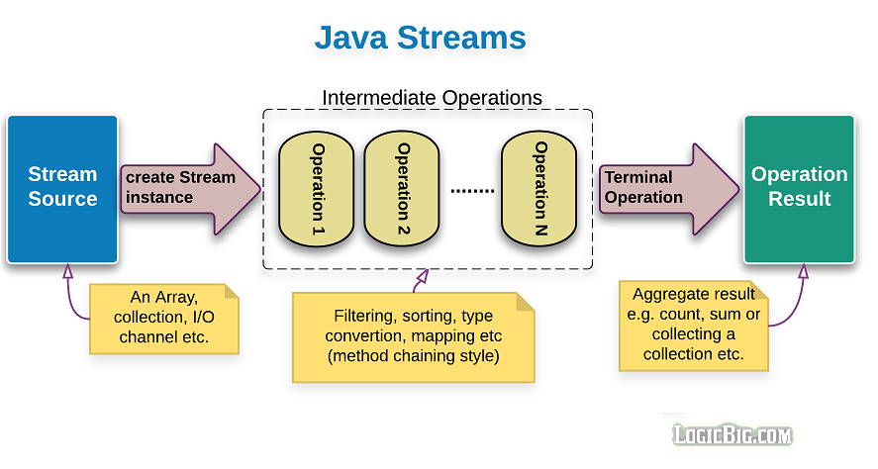
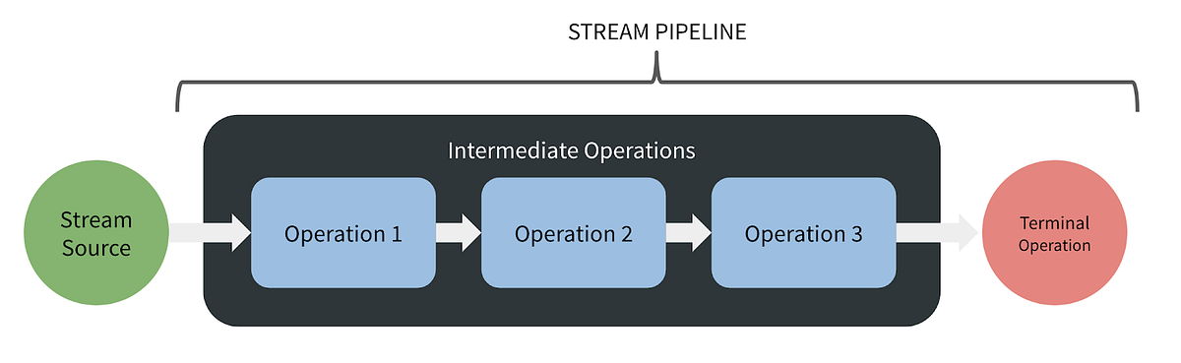

2. Creating Streams

From Collection
List<String> names = List.of("Java","Python","Go");

Stream<String> stream = names.stream();

From Array
int[] numbers = {1,2,3,4};

IntStream stream = Arrays.stream(numbers);

Using Stream.of()
Stream<String> stream = Stream.of("A","B","C");

Infinite Streams
Stream.iterate(1, n -> n + 1)
.limit(5)
.forEach(System.out::println);
Output
1 2 3 4 5

3. Intermediate Operations
Intermediate operations transform streams.
Examples:
Operation | Purpose
filter() | Select elements
map() | Transform elements
sorted() | Sort elements
distinct() | Remove duplicates
limit() | Limit results
skip() | Skip elements

Example
List<Integer> numbers = List.of(5,2,8,1,4);

numbers.stream()
.filter(n -> n > 3)
.sorted()
.forEach(System.out::println);
Output
4
5
8

4. Terminal Operations
Terminal operations produce a result.
Examples:
Operation | Purpose
forEach() | Iterate
collect() | Convert to collection
count() | Count elements
reduce() | Aggregate values
findFirst() | Get first element
anyMatch() | Match condition

Example
List<Integer> numbers = List.of(1,2,3,4,5);

int sum = numbers.stream()
.reduce(0, Integer::sum);

System.out.println(sum);
Output
15

5. Map vs FlatMap

Map
Transforms each element.
List<String> names = List.of("java","python");

names.stream()
.map(String::toUpperCase)
.forEach(System.out::println);
Output
JAVA
PYTHON

FlatMap
Flattens nested structures.
List<List<Integer>> numbers = List.of(
List.of(1,2),
List.of(3,4)
);

numbers.stream()
.flatMap(List::stream)
.forEach(System.out::println);
Output
1
2
3
4

Map vs FlatMap Diagram
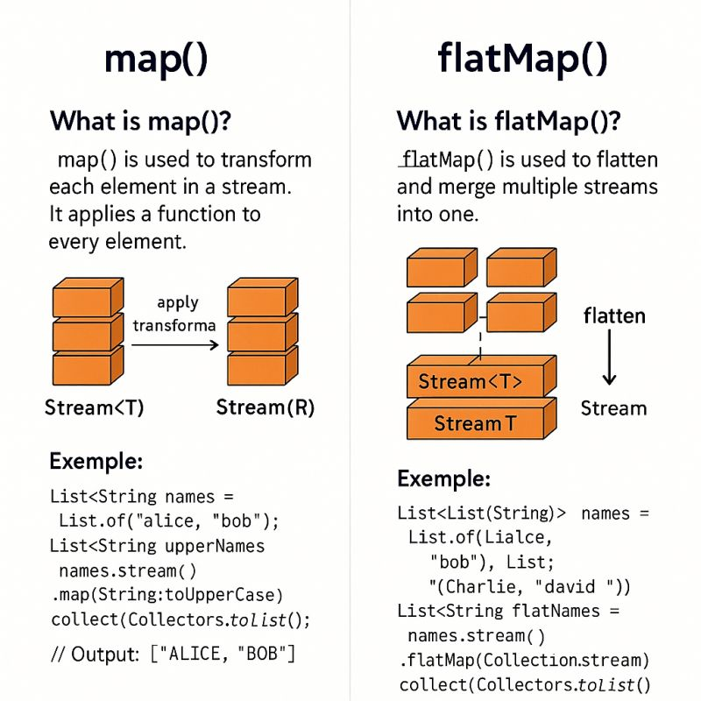
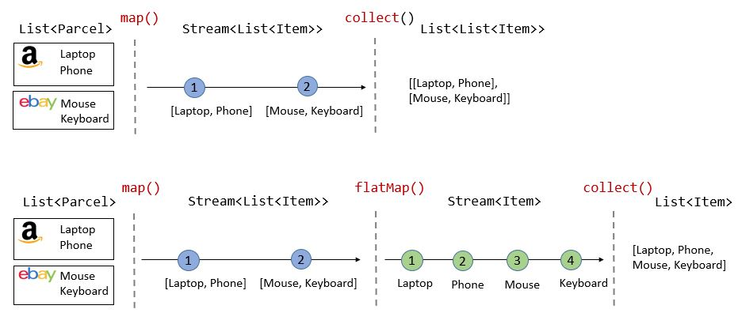
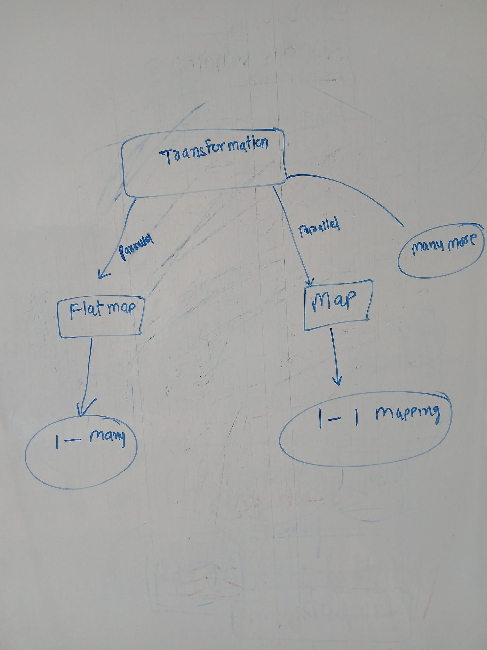
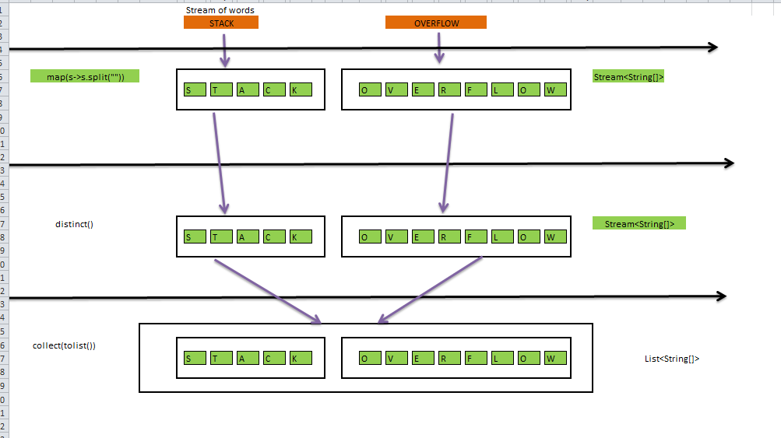

6. Collectors
Collectors convert streams to collections.
Common collectors:
Collector | Purpose
toList() | Convert to list
toSet() | Convert to set
joining() | Combine strings
groupingBy() | Group elements
partitioningBy() | Split into true/false

Example
List<String> names = List.of("Java","Python","Go");

List<String> result =
names.stream()
.filter(s -> s.length() > 3)
.collect(Collectors.toList());

System.out.println(result);
Output
[Java, Python]

7. Grouping with Streams
Example: group employees by department.
Map<String, List<Employee>> grouped =
employees.stream()
.collect(Collectors.groupingBy(Employee::getDepartment));

Grouping Operation Diagram
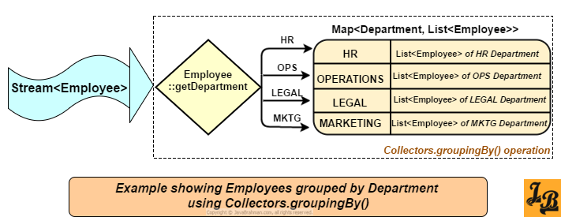
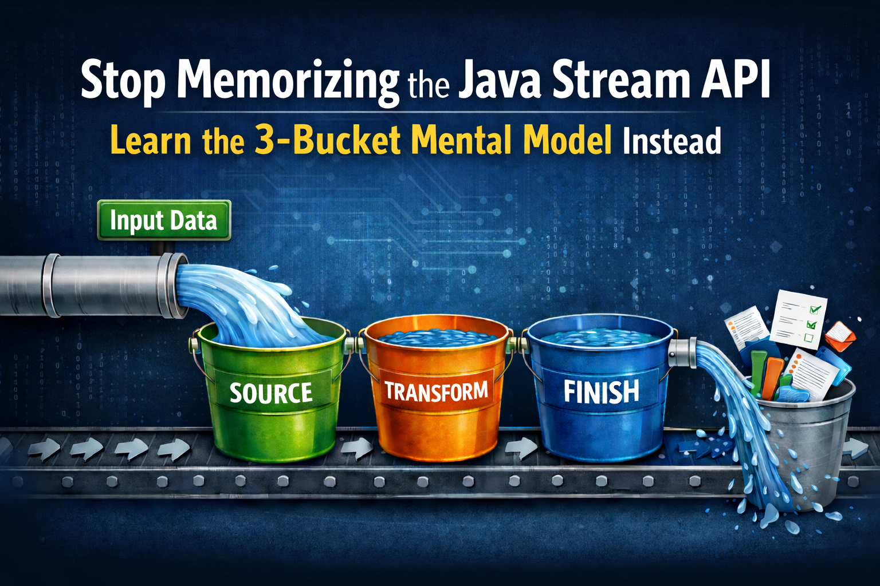
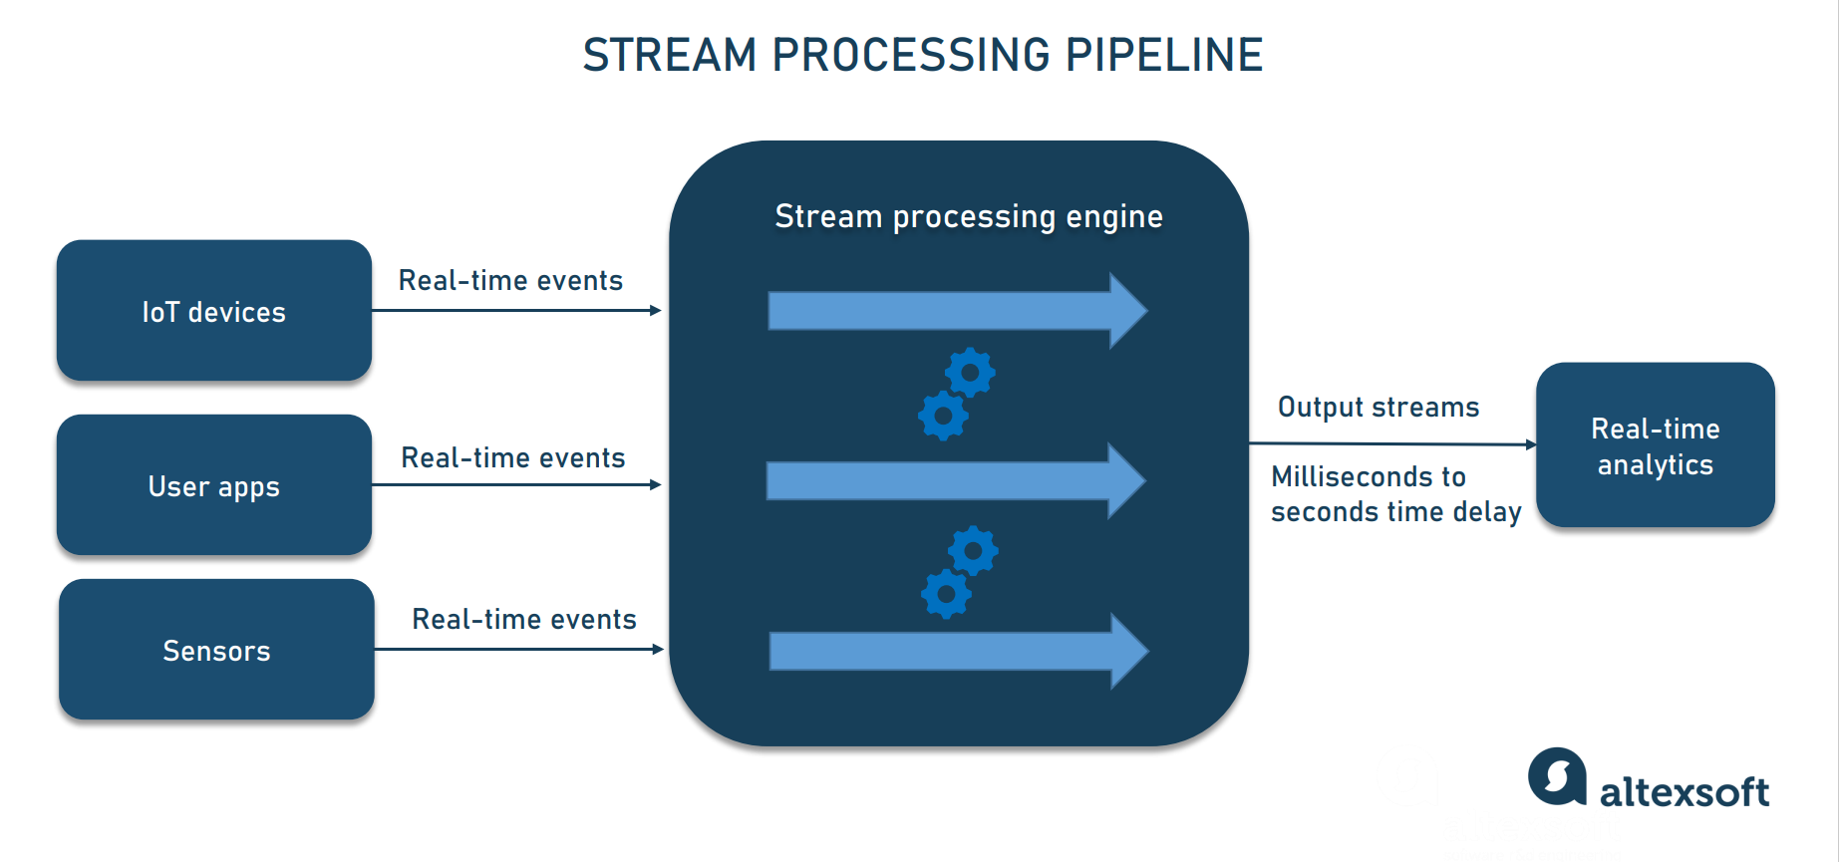
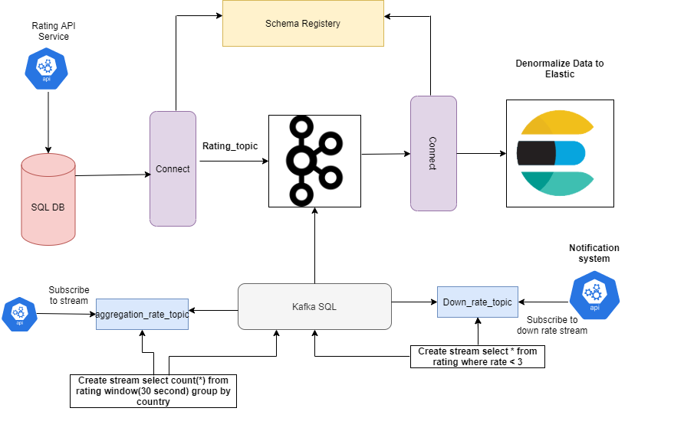

8. Parallel Streams
Streams support parallel processing.
numbers.parallelStream()
.forEach(System.out::println);
Useful for large datasets and CPU-intensive tasks.

9. Example: Real Java Stream Program
Find top 3 highest numbers.
List<Integer> numbers = List.of(5,8,2,10,7);

numbers.stream()
.sorted((a,b) -> b - a)
.limit(3)
.forEach(System.out::println);
Output
10
8
7

10. Real Industry Example

E-commerce Order Processing
Operations:
Orders → Filter completed orders
→ Map to order amount
→ Calculate total revenue
Example:
double totalRevenue =
orders.stream()
.filter(order -> order.isCompleted())
.map(Order::getAmount)
.reduce(0.0, Double::sum);

50 Advanced Java Collections Coding Problems
Below are commonly asked Java interview coding questions.

ArrayList Problems
- Remove duplicates from ArrayList
- Find second largest number in List
- Reverse ArrayList without Collections.reverse
- Sort list in descending order
- Merge two ArrayLists
- Find common elements between lists
- Rotate ArrayList
- Find frequency of element in list
- Remove null elements
- Convert List to Map

HashMap Problems
- Count frequency of characters in string
- Find first non-repeating character
- Group words by length
- Find duplicate elements using HashMap
- Implement LRU cache using LinkedHashMap
- Sort HashMap by value
- Find highest occurring word
- Count word frequency in paragraph
- Reverse HashMap
- Convert Map to List

HashSet Problems
- Remove duplicates from array using HashSet
- Check if two arrays share common element
- Find union of two sets
- Find intersection of sets
- Find difference between sets

LinkedList Problems
- Reverse LinkedList
- Detect cycle in LinkedList
- Find middle node
- Merge two sorted linked lists
- Remove nth node from end

Stream API Problems
- Find longest string in list
- Find duplicate numbers using streams
- Convert list of objects to map
- Group strings by length
- Find top 5 highest numbers
- Partition numbers into even and odd
- Find average of list
- Find first non-repeated character
- Sort employees by salary
- Find max salary employee

Advanced Collection Problems
- Implement custom HashMap
- Implement stack using LinkedList
- Implement queue using two stacks
- Find Kth largest element
- Sliding window maximum
- Implement LRU cache
- Top K frequent elements
- Find pair with given sum
- Group anagrams using HashMap
- Merge overlapping intervals

Example Coding Problem

Count Frequency of Characters
import java.util.*;

public class CharFrequency {

public static void main(String[] args) {

String str = "programming";

Map<Character,Integer> map = new HashMap<>();

for(char c : str.toCharArray()) {

map.put(c, map.getOrDefault(c,0) + 1);
}

System.out.println(map);
}
}
Output
{p=1, r=2, o=1, g=2, a=1, m=2, i=1, n=1}

Example Stream Problem
Find duplicate numbers.
List<Integer> numbers =
List.of(1,2,3,4,2,5,3);

numbers.stream()
.filter(n -> Collections.frequency(numbers,n) > 1)
.distinct()
.forEach(System.out::println);
Output
2
3

